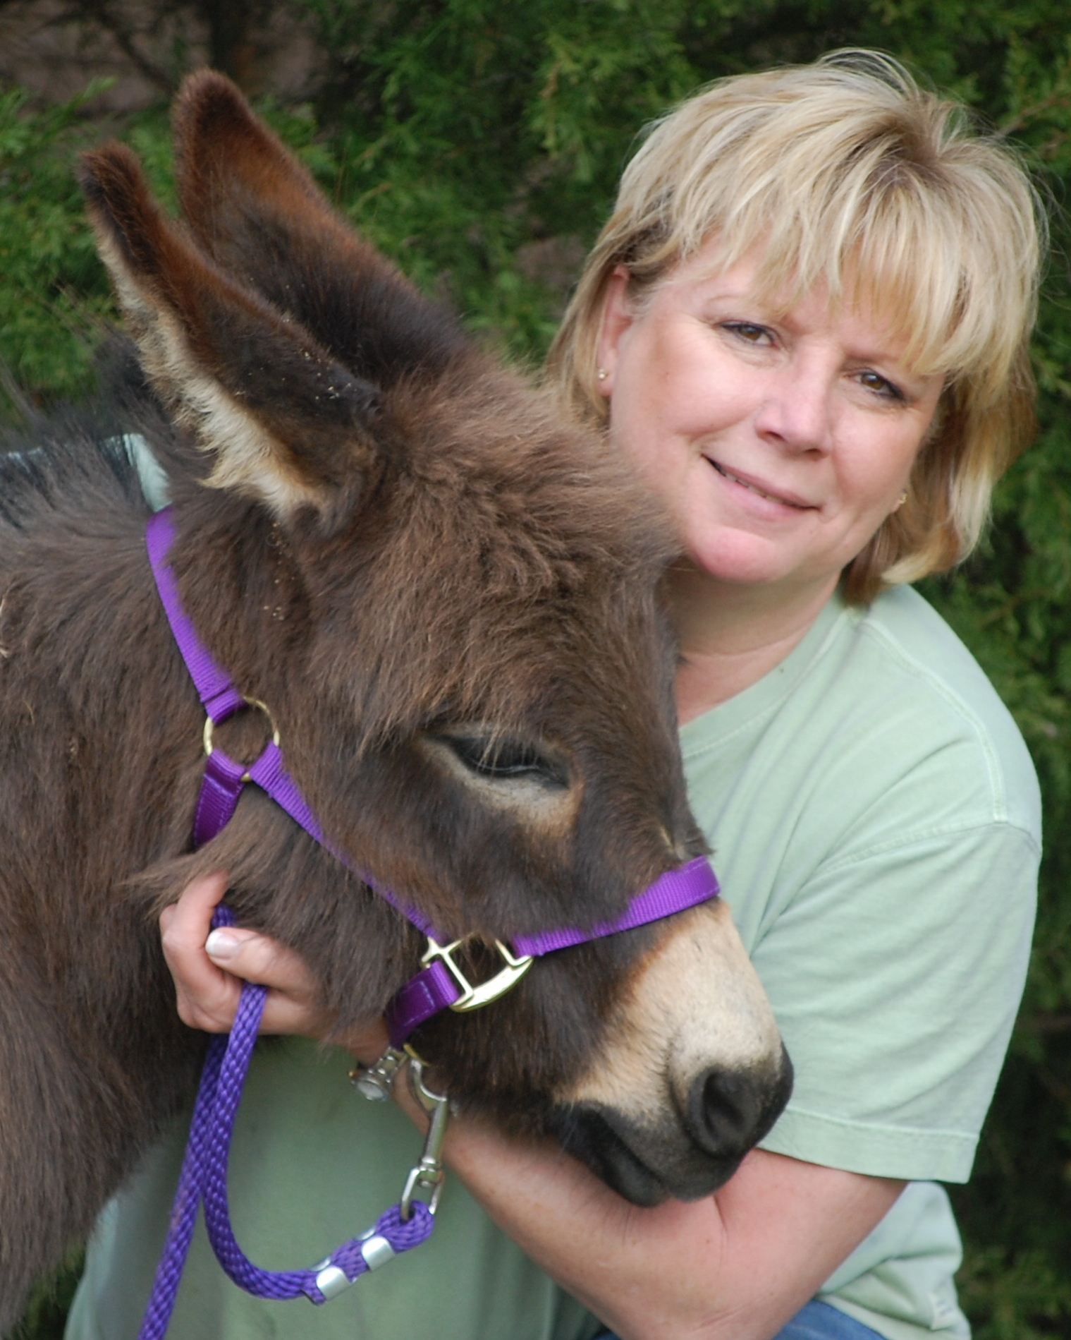
Hi everyone! My name is BarkNBray Yummy Hot Chocolate – AKA – Nestle. I was born on February 23, 2008 in Campbell, MO. My first human Mom, Dianne Robbins, knew from the very beginning that I was going to be very special Miniature Mediterranean donkey. Over and over again, it was explained to me that someday, something extraordinary was going to happen in my life.

I didn’t know what she meant by that until I moved to Debb Taylor’s (my new Mom) house in Arlington, TN. She told me that I was going to be her very first registered therapy donkey. I was so excited, although I didn’t know exactly what she meant. I watched my 4 Golden Retriever brothers and sisters leave with her at different times throughout the week. They would get to go to play with kids in the hospital, see older people when they were sick and sometimes they even got to go libraries and schools and have kids read to them. They would come home and tell me all kinds of stories about the fun they had. I decided that I needed to find out what this therapy donkey stuff was about.

My Mom seemed to read my mind and she started my therapy training. The first thing I had to learn was how to wear my halter and lead with a lead rope. Then I learned what “stay” and “come – let’s go” meant and how to do them when told. I learned how to get in and out of my donkey trailer willingly without being pulled. I learned that loud strange noises weren’t such a scary thing and that crutches and wheel chairs weren’t going to hurt me. My favorite thing ever is being brushed, so I didn’t have to work too hard on that. I also didn’t have much problem accepting strange people that Mom brought in to meet me. In fact, most of them had these great treats that made me think to myself – “if I act scared, Mom will think I need more training and then I’ll get more treats.” She caught on to that pretty quick though! There was one kind of scary thing that Mom did to me – she took this big blanket and waved it all over and then threw it over my back and let it slide off. I thought – “what was that all about??” – But I stood still and showed her that I could be very brave.

Finally, she told me that I was ready for my therapy animal evaluation. Again, I was so excited, although I didn’t really know what that meant either. But, she loaded me up in my trailer and took me to this very strange place, called DogWoods Training Center. I thought to myself, “Why am I going to a dog training place to become a therapy donkey?” Well, it turns out that I had to be tested in a place that I wasn’t familiar with so they could see my true skills and aptitude for therapy work. The test took about an hour, but I remembered everything that Mom and I had practiced and I did really well. She was very nervous, which I didn’t understand – I wasn’t nervous at all. In fact, I met some really nice people that talked to me, petted me, hugged me, brushed me and at the end they gave me this great treat. They did some kind of strange, scary stuff in between all of that, but I handled it like a true therapy donkey.

Finally, my evaluator finished all of her paperwork and told me and Mom that we had passed and I was now an official therapy donkey. Mom was so proud of me – she told me over and over what a great little therapy donkey I was. If donkeys could smile, I would be grinning from big, long ear to big, long ear. I can’t wait until my first therapy visit!!

I would like to thank my first Mom, Dianne Robbins, for recognizing that I was something very special from the beginning and for letting me go to such a wonderful family that would love me so much and teach me the skills that I need to be the BEST THERAPY DONKEY ever!!

